**Experiment No.** 02

**Name of the Experiment**: Designing and implementing metal detector circuit using 555 Timer (NE555) on a PCB

**Objectives:**

* To know how to design metal detector circuit using 555 timer on PCB designing software
* To understand the operation of metal detector circuit using 555 timer
* To learn the various steps of PCB designing process

**Theory:**

**Metal detector circuit:**

Metal detectors are gadgets that is capable of detecting metal elements on a surface. The proximity at which the detectors can detect metals depends on the detector’s range it can cover. Here in this Metal detector circuit, we are using a timer IC 555 and Inductor to detect metals and alert the user by means of an alarm from simple buzzer. [1]

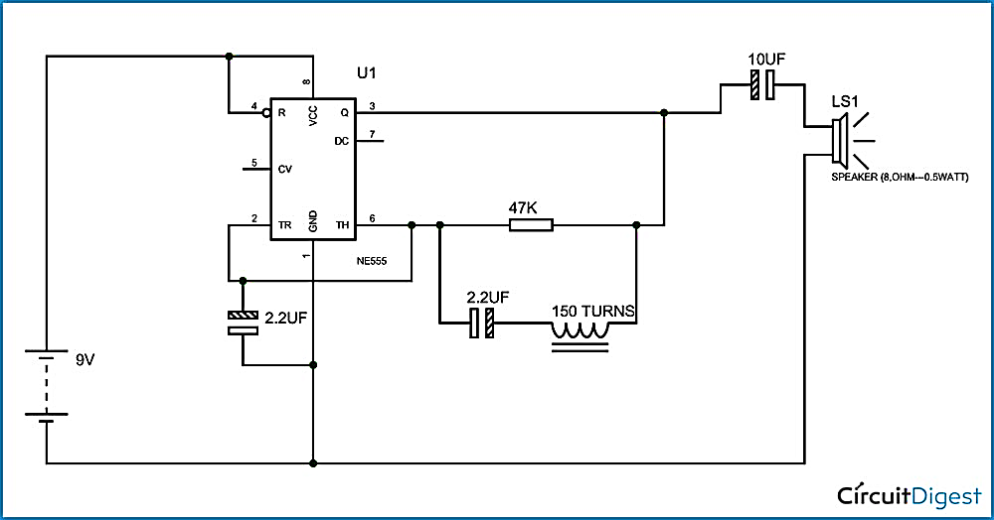

**Fig.1.1: The schematic of the IC 555 in metal detector circuit** [2]

The 555 IC timer here functions as a square wave generator, producing pulses with audible frequency. Because audible frequencies must be generated, the capacitor between pins 2 and 1 should not be modified.

An RLC circuit is produced in the circuit by a 47K resistor, a 2.2F capacitor, and a 150turn inductor. The metal detector component is this RLC circuit. As previously stated in the preceding section, a metal core inductor has a higher inductance value than an air cored inductor.

Because the coil wound here is an air cored one, bringing a metal piece close to the coil functions as a core for the air cored inductor. The inductance of the coil varies or increases significantly as a result of this metal serving as a core. As the inductance of the coil suddenly increases, the overall reactance or impedance of the RLC circuit changes significantly when compared to when the metal piece is not there.

When there is no metal piece, the signal sent to the speaker produces some audible sound at first. Because of the reactance change in the RLC circuit, the signal delivered to the speaker will no longer be the same as before, and the sound generated by the speaker will differ from the previous one. So, whenever a metal is placed close to the coil, the impedance of the RLC varies, causing the signal to vary and resulting in variations in the sound produced by the speaker. [2]

**PCB design:**

An electronic circuit consists of thin strips of a conducting material such as copper, which have been etched from a layer fixed to a flat insulating sheet called a printed circuit board, and to which integrated circuits and other components are attached.

In other words, a printed circuit board (PCB) or printed wiring board (PWB) is a laminated sandwich structure of conductive and insulating layers. PCBs have two complementary functions. The first is to affix electronic components in designated locations on the outer layers by employing soldering. The second is to provide reliable electrical connections (and also reliable open circuits) between the component's terminals in a controlled manner often referred to as PCB design.

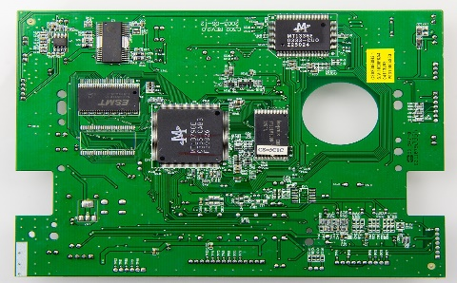

**Fig 1.2: PCB design [3]**

A printed circuit board (PCB) mechanically supports and electrically connects electronic components using conductive tracks, pads, and other features etched from copper sheets laminated onto a non-conductive substrate. A printed circuit board has pre-designed copper tracks on a conducting sheet. The pre-defined tracks reduce the wiring thereby reducing the faults arising due to losing connections. One needs to simply place the components on the PCB and solder them.

Printed circuit boards are used in nearly all electronic products and in some electrical products, such as passive switch boxes.

Importance of PCBs design:

* People face problems while making a circuit on a breadboard like a circuit may work sometimes and may not work other times.
* Either the connection is not proper or loose or may get damaged while working or carrying the circuit on a breadboard.
* PCB made breadboard connection permanent.
* Mass-producing circuits with PCBs are cheaper and faster than with other wiring methods
* Before the advent of the PCB, circuits were constructed through a laborious process of point-to-point wiring. This led to frequent failures at wire junctions and short circuits when wire insulation began to age and crack

**Required Apparatus:**

* Proteas
* PCB board
* 555 Timer IC (NE555)
* Resistors (10KΩ-1piece, 1KΩ-1piece, 47KΩ-1piece)
* Capacitors (10µF-2pieces, 2.2 µF-2pieces)
* Speaker (8Ω, 1watt-1 piece)
* Battery (9V)
* LED Bulb (1piece)

**Circuit Diagram:**

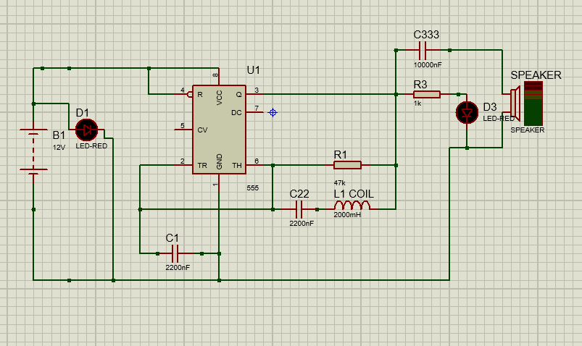

**Fig 02: Circuit diagram of metal detector circuit using 555 Timer (NE555)**

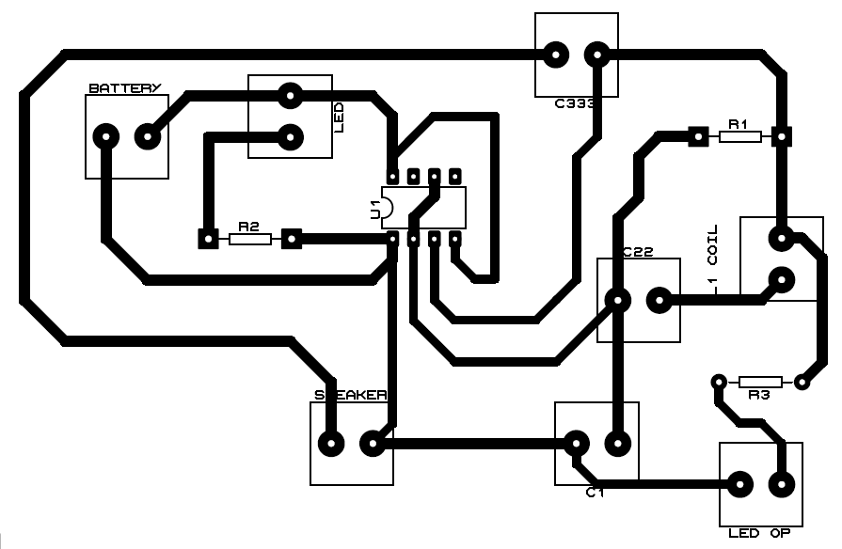

**Fig 03: Circuit diagram of metal detector circuit using 555 Timer (NE555) (PCB layout)**

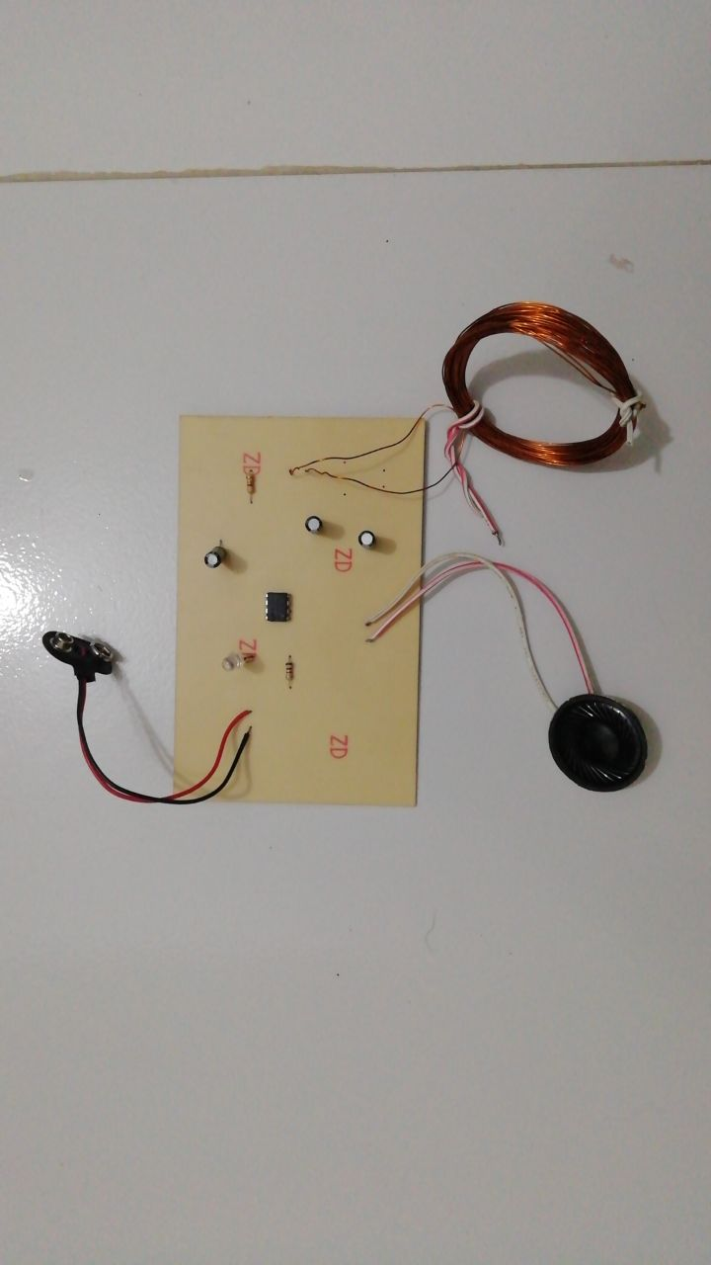

**Fig 04. Implemented circuit of Metal detector circuit using 555 timer with component (Top view)**

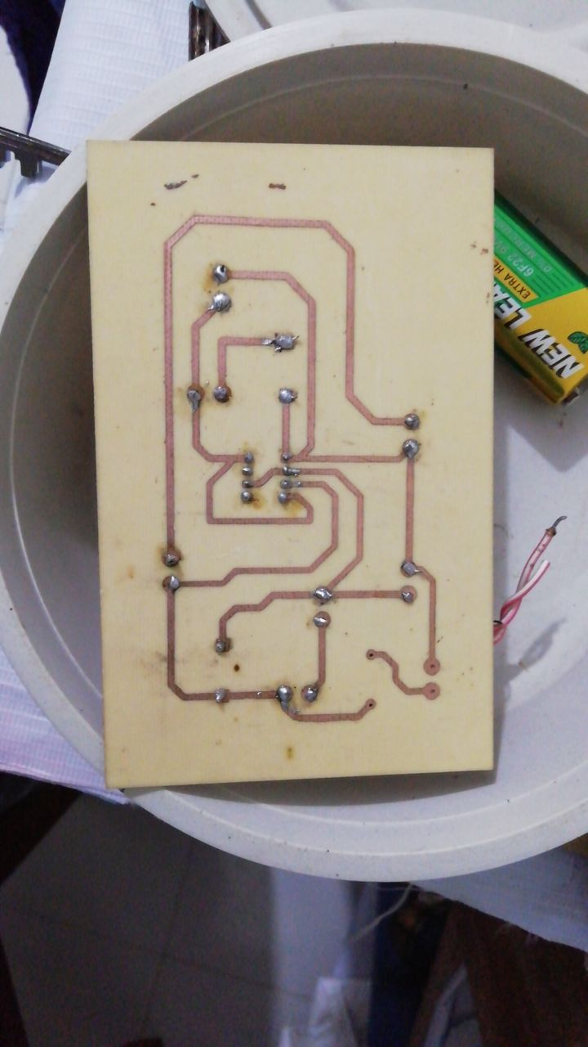

**Fig 05. Implemented circuit of Metal detector circuit using 555 timer with component (Bottom view)**

**Procedures:**

**Step 1: Design the circuit in Proteus platform:**

PCB design is often accomplished by translating the schematic diagram of your circuit into a PCB layout utilizing PCB layout software. There are numerous interesting open-source software tools available for PCB layout generation and design. The initial stage in this experiment is to design the circuit of the astable multivibrator in the Proteus platform using the relevant components. The design was then used to produce a PCB layout.

**Step 2: Print from File to Film:**

The PCB layout was printed using a laser on a specific type of paper called Glossy or Photo paper. The following points are taken into consideration:

1. No mirror printout was taken.

2. The black output from both the PCB design software and the printer driver settings.

3. The printed page is on the glossy side of the paper.

**Step 3: Pressing the print on CCB board:**

The pattern was printed on copper clad board (CCB) with an ai iron. After printing on glossy paper, iron the picture side down to the copper side, then heat the electric iron to the highest setting. Hold one end with pliers or a spatula and keep it steady. Then, for about 10 seconds, place the hot iron on the other end. Now, iron the photo paper all the way along with the tip and a little pressure for 5 to 15 minutes.

**Step 4: Etching:**

Care was taken while performing the steps of etching.

* First, put on rubber or plastic gloves.
* Place some newspaper on the bottom so the etching solution does not spoil your floor.
* Take a plastic box and fill it up with some water.
* Dissolve 2-3 teaspoons of ferric chloride (FeCl3) power in the water. Dip the PCB into the etching solution (Ferric chloride solution, FeCl3) for approximately 30 mins. The FeCl3 reacts with the unmasked copper and removes the unwanted copper from the PCB.
* This process is called Etching. Using pliers to take out the PCB and check if the entire unmasked area has been etched or not. In case it is not etched, leaving it in the solution for some more time.
* Gently move plastic box to and fro so that etching solution react with exposed copper and form iron and copper chloride (cupric chloride, CuCl3)

As a result, the unwanted copper was removed that remained on the board. A chemical solution, similar to the alkaline solution was used to remove the unwanted copper.

**Step 5: Drilling:**

Holes were drilled into the layers by a drill machine to expose the substrate and inner panels. Any remaining copper after this step was removed.

**Step 6: Soldering:**

Soldering is the joining of two or more metal items by melting and pouring a filler metal (solder) into the joint, the filler metal having a lower melting point than the workpiece. Solder is a metal alloy (typically) consisting of tin and lead that is melted with a hot iron. The iron is heated above 600 degrees Fahrenheit and then cooled to form a strong electrical connection.

The components were put on the CCB in accordance with the astable multivibrator's design. During soldering, components such as soldering iron, sucker, resin, and soldering wire were used.

**Step 7: Testing:**

Finally using power supply and oscilloscope the design was tested that it works properly or not.

**Observation:**

The tone of the speaker was heard after the power was connected. A variation in tone was heard anytime a metal conductor was moved between the coil's air gap. This tone due to metals’ appearance was slightly faster than the non-metal tone. The presence of metal in front of the detector is indicated by this change in tone.

**Discussion and Conclusion:**

In that experiment a metal detector circuit was designed and the operation and different characteristics of the circuit were observed due to movement of the metal. Inductor acts as an air core. After supply is connected, a magnetic field proportionate to the current flow emerges around the inductor when current runs through it. Thus, whenever a metal is introduced close to an inductor, the magnetic field detects an increase in inductance. This causes an increase in current flow, and the capacitor begins charging quickly. Feeding the IC 555's trigger pin. [1]

The duty cycle of the output pulse that goes to the speaker changes as the inductance changes. We can hear a difference in the tone of the speaker. This shift in tone indicates the presence of metal in front of the detector. [1]

Some difficulties were faced by us designing the PCB regarding the printing paper. It is very important to print the design on appropriate paper. Following the processes very carefully after having some errors the experiment was done successfully at last.

**Reference:**

[1] <https://www.gadgetronicx.com/metal-detector-circuit-ic-555-buzzer/>

[2] <https://circuitdigest.com/electronic-circuits/simple-metal-detector-circuit/>

[3] <https://www.venture-mfg.com/hardware-pcb/>